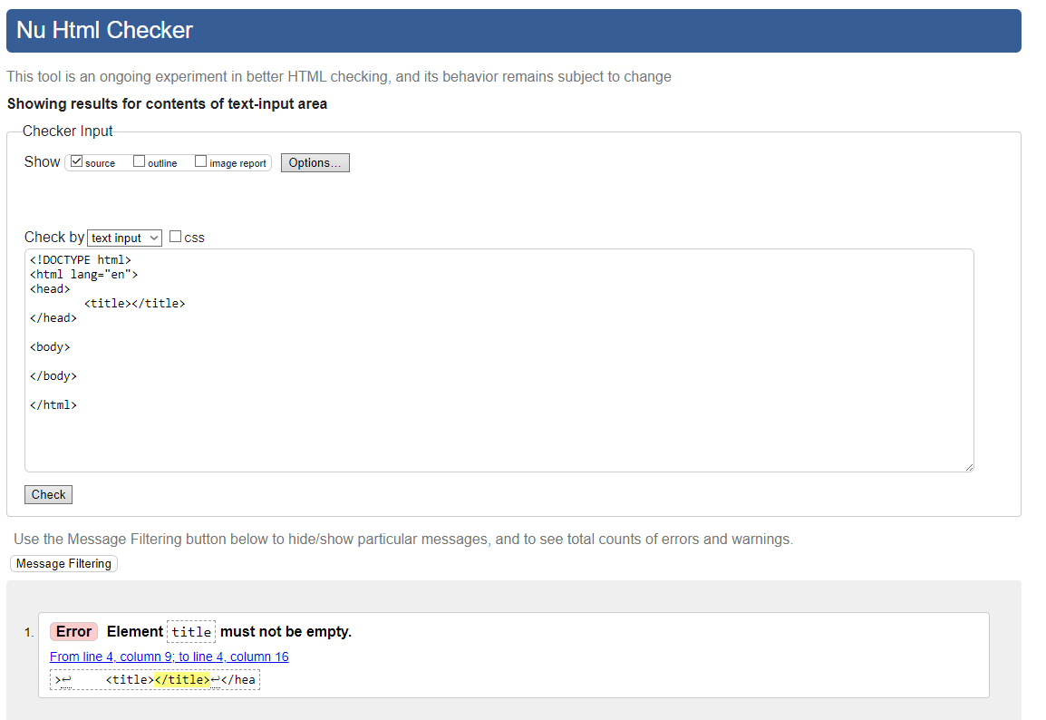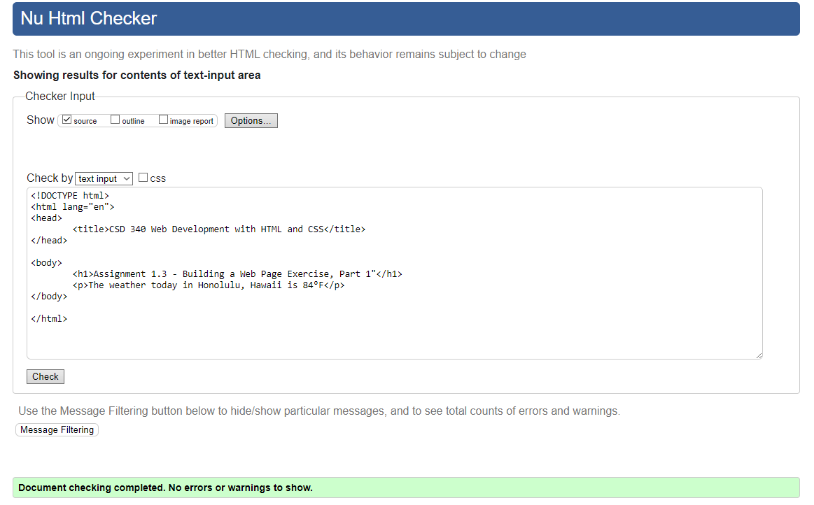GitHub Repository: <https://github.com/Kliz0409/CSD-3401.git>